**Project Schedule**

**Project task set:**

Major Tasks in the Project stages are:

* Task 1: correctness
* Task 2: availability
* Task 3: integrity

**Task network:**

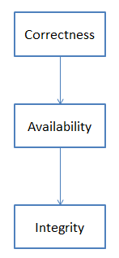

**Timeline Chart:**

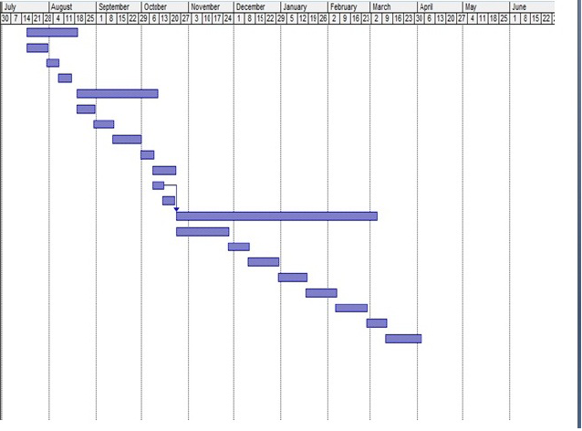

**Team Organization:**

Team consists of 4 members and proper planning mechanism are used and roles of

each member are defined.

**Team structure:**

The team structure for the project is identified. There are total 4 members in our team and roles are defined. All members are contributing in all the phases of project.

|  |  |  |  |
| --- | --- | --- | --- |
| Month Scheduled | Phase | Name of Group Members | Work done |
| June-August | Topic searching |  | Topic Searched |
| August-September | Topic selection |  | Topic Selected |
| August-September | Project confirmation |  | Project Confirmed |
| August-September | Literature Sur-  Vey |  | Literature Sur-  vey Done |
| September-October | Requirement  Analysis |  | Requirement  Analysis Done |
| September-October | Requirement  Gathering |  | Requirements  Gathered |
| November-December | Designing |  | Architecture Design |
| November-December | Designing Test |  | GUI Tested |
| November-December | Database Creation |  | Database Tested |
| January-February | Coding |  | Coded Different modules |
| January-February | Database And Modules Connectivity |  | Connectivity Done |
| March | Testing of project |  | Project Tested |
| April | Result Analysis |  | Result Analysis |

**Management reporting and communication:**

Well planning mechanisms are used for progress reporting and inter/intra team communication are identified as per requirements of the project.